A89-ME-Phoenicia-Glass-Jar-Amulet-100 BCE

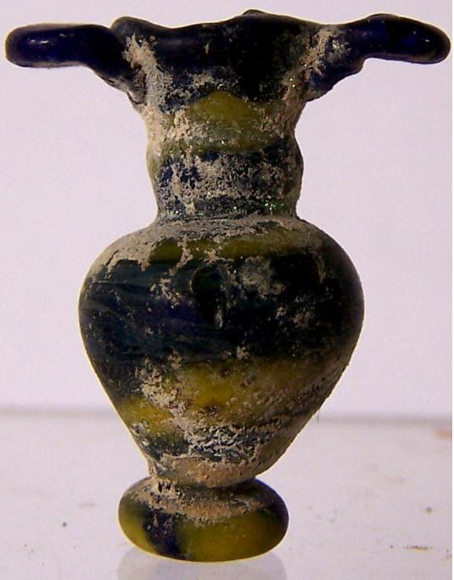

Case no.:4

Accession Number: A89

Formal Label: ME-Phoenicia-Glass-Amulet jar

**Display Description:** *Ṣīḏōn* (Σιδών' “fishing-town”. In Roman times, Sidon was an entrepreneurial town that was famous for its manufactures and arts, as well as for its commerce (1 Kings 5:6; 1 Chronicles 22:4; Ezekiel 27:8). that produced fine glass such as this diminutive amulet jar displaying the Phoenician penchant for glassblowing techniques that mixed two or more colors.

**LC Classification:** NK4017.2.P65

Date or Time Horizon: 100 BCE

Geographical Area: Sidon

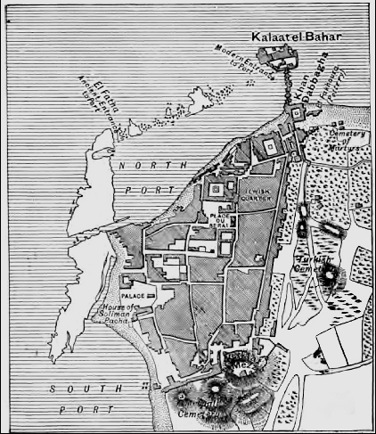

**Map from http://www.bible-history.com/ibh/images/fullsized/plan-of-sidon.jpg**

**GPS coordinates:** [33°33′38″N 35°23′53″E](https://tools.wmflabs.org/geohack/geohack.php?pagename=Sidon&params=33_33_38_N_35_23_53_E_region:LB_type:city(80000))

Cultural Affiliation: Sidonian, Phoenician

Media: glass

Dimensions: 2.7cm

Weight: 2 g

Condition: original

Provenance: Lebanon collection

**Discussion:**

Sidon’s origin has been documented to Paleolithic **Sidon II** "near the church" by P. E. Gigues who dated this site to the Acheulean. The Neolithic **Sidon I** city, has been identified by an assemblage of flint tools found by P. E. Gigues dating to 3800-3200 BCE including narrow chisels that were unifacially polished and flaked (cf. Ain Cheikh, Nahr Zahrani and Gelal en Namous). Phoenician religion and worship was accorded a prominent place by Solomon ca 900 BCE, who entered into a matrimonial alliance with a Sidonian woman (1 Kings 11:1, 33), similar to the fetching Jezebel, a Sidonian princess (1 Kings 16:31). Conversely, Sidonian religion is frequently disparaged by the prophets (Isaiah 23:2, 4, 12; Jeremiah 25:22; 27:3; 47:4; Ezekiel 27:8; 28:21, 22; 32:30; Joel 3:4). Many Sidonians came to hear Jesus when he visited the "coasts" of Tyre and Sidon ([Matthew 15:21](http://bible.oremus.org/?passage=Matthew+15:21–15:21&version=nrsv); [Mark 7:24](http://bible.oremus.org/?passage=Mark+7:24–7:24&version=nrsv)) (Mark 3:8; Luke 6:17), (cf. [Matthew 11:21–23](http://bible.oremus.org/?passage=Matthew+11:21–23:21&version=nrsv) to [Korazin](https://en.wikipedia.org/wiki/Korazin) and [Bethsaida](https://en.wikipedia.org/wiki/Bethsaida)). Saul of Tarsus sailed for Rome (Acts 27:3, 4) from Sidon, confirming its long-distance shipping trade with Rome.

**References:**

Eiselen, Frederick Carl. 1907. *Sidon: A Study in Oriental History*, V. 4. New York: Columbia University Press.

Copeland, Lorraine and P. Wescombe. 1965. *Inventory of Stone-Age sites in Lebanon*. Paris: Imprimerie Catholique.

Kelly, Thomas. 1987. “Herodotus and the Chronology of the Kings of Sidon,” *Bulletin of the American Schools of Oriental Research*, no. 268: 39–56.

**PA**: .4